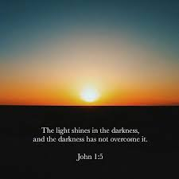
Please mark your calendar and join the Episcopal Cursillo Ministry of The Diocese of East Carolina for a ZOOM Grand Ultreya. Register in advance click below

BE THE LIGHT
For there is always light
If only we are brave enough to see it
If only we are brave enough to be it

https://us02web.zoom.us/meeting/register/tZIlcuuhrzsjH9JJqmiExQ2slYC1Z6B1xhq-
Time: Gather/Check In 9:45 AM
10 AM Start time. Welcome from Bishop Skirving
Singing, Floating Reunion, Lay Witness by Lisa Richey, Clergy Response by Reverend Malone Gilliam and Lay Response by Sandra Loucks

